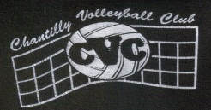 Chantilly Volleyball Club Summer Program
CVC will open registration for boys of all levels starting on 15 May. All clinics will be held at Rachel Carson MS in Herndon. Specific dates and times will be published when they become available.
Sessions (check one):
- ES Boys
- MS Boys
- HS Boys

The fee is $100 per player ($130 if you live outside of Fairfax County). Players receive a Molten Flistatec volleyball and a team shirt. To register: Please email this form to pagefedors@hotmail.com ASAP. Please do not print the form or send PDF’s – thanks!
Please mail a check written to Melissa Fedors to 13002 Feldspar Ct, Clifton, VA 20124.
The deadline for registration is 1 June.
Player Information
Name
Address
Phone |  | Age | Grade
Email
Shirt Size | Youth Sizing: yes no | Highlight size: | S M L XL XXL other
Parents’ Names

